**R.VINOD REDDY, *Advocate***

**Standing Counsel for TSTRANSCO/TSSPDCL**

**H.No.8-2-684/4/31, Plot No.26, Anand Banjara,**

**Road No.12, Banjara Hills, Hyderabad – 500034**

*Ph: 040-23304342*

*9849041514*

**Advance Receipt**

*Date: 29-02-2020*

Received a sum of **Rs. 10000/-** (Rupees Ten Thousand only) from superintending Engineer, Operation, Saroornagar, TSSPDCL towards filing Counter affidavit in WP. No. 8090 of 2019 filed by Gurram Buchi Reddy and others before Honorable High Court.

1. Legal Fee : Rs. 5000=00
2. Filing Expenses : Rs 5000=00

**Total : Rs. 10000=00**

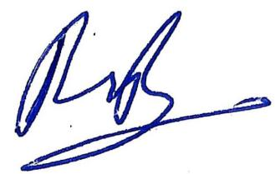

**(R.Vinod Reddy)**